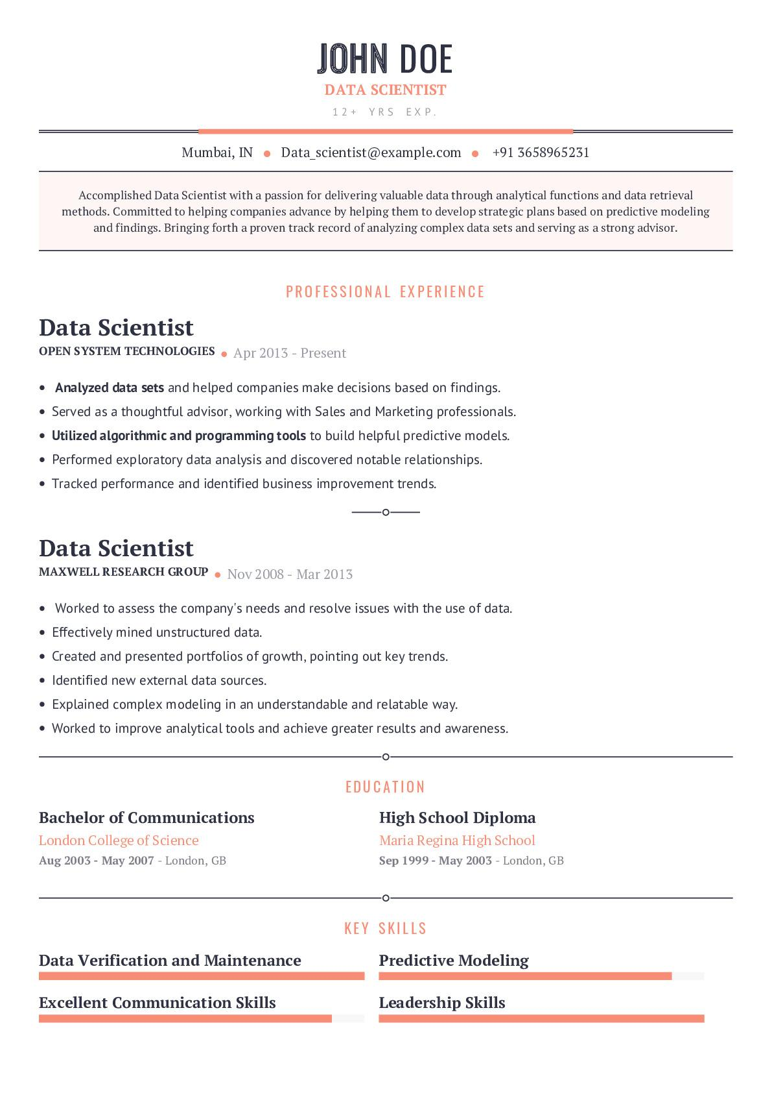
JOHN DOE
DATA SCIENTIST
12+ YRS EXP.
Mumbai, IN Data_scientist @example.com. +91 3658965231
Accomplished Data Scientist with a passion for delivering valuable data through analytical functions and data retrieval methods. Committed to helping companies advance by helping them to develop strategic plans based on predictive modeling and findings. Bringing forth a proven track record of analyzing complex data sets and serving as a strong advisor.
PROFESSIONAL EXPERIENCE
Data Scientist
OPEN SYSTEM TECHNOLOGIES. Apr 2013 - Present
• Analyzed data sets and helped companies make decisions based on findings. • Served as a thoughtful advisor, working with Sales and Marketing professionals. • Utilized algorithmic and programming tools to build helpful predictive models.
• Performed exploratory data analysis and discovered notable relationships.
• Tracked performance and identified business improvement trends.
Data Scientist
MAXWELL RESEARCH GROUP. Nov 2008 - Mar 2013
• Worked to assess the company's needs and resolve issues with the use of data.
• Effectively mined unstructured data.
• Created and presented portfolios of growth, pointing out key trends.
Identified new external data sources.
• Explained complex modeling in an understandable and relatable way.
• Worked to improve analytical tools and achieve greater results and awareness.
Bachelor of Communications
London College of Science
Aug 2003 May 2007 - London, GB
Data Verification and Maintenance
Excellent Communication Skills
EDUCATION
High School Diploma
Maria Regina High School
Sep 1999 - May 2003 - London, GB
KEY SKILLS
Predictive Modeling
Leadership Skills

